Year 10
Pathway 2

Mini Test 10- Sketching non-linear relationships

2019


Name: ______________________ Class: ______ Time: 45 minutes Total Mark:____/38

Show working and answers on this sheet. Show working in sufficient detail to support your answers. Incorrect answers without supporting reasoning will be allocated zero marks.

Resources: 1 A4 page of notes (2 sided), Calculator allowed.

Section 1: Multiple Choice (choose just one answer) 7 Marks
- Which of the following equations is a parabola?
  - y = 2x + 4
  - y = 2x³ + 4
  - y = 2x² + 4
  - y = 2^{x}

- Which is the most basic equation of a parabola?
  - y = x²
  - y = 2x² + 3
  - y = -x² -4
  - y = -x²

- What is the turning point of graph 1?
Graph 1
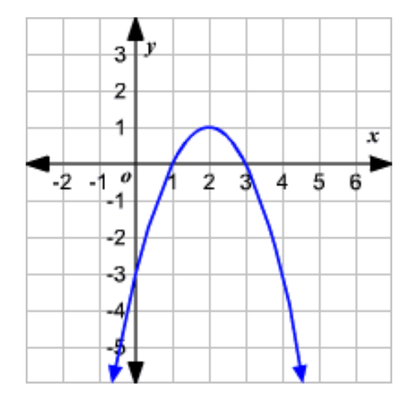
  - x=2
  - y=-3
  - (2, 1)
  - y=1

- What are the coordinates of the y-intercept of graph 1?
  - (-3, 0)
  - (0, -3)
  - (2, 1)
  - y=-3

- What are the x-intercepts for this graph of graph 1?
  - 1 and 3
Graph 1
  - 1 and -3

  - 0 and -3
  - 0 and 3

- Does this graph show a maximum or a minimum?
  - Maximum
  - Minimum

- What is the axis of symmetry for this graph?
  - y=2
  - x=2
  - x=0
  - y=0

Section 2: Short Answer

Question 8 10 marks- 3, 3, 1, 3
Consider the equation y = 2x2 – 8 and complete the following questions on the Cartesian plane on the next page.
- Set up a table of values with x-values from -3 to 3.
- Plot the points on a coordinate plane and label the graph.
- Find the turning point of the graph and label them.
- Determine the x- and y-intercepts for the graph and label them.

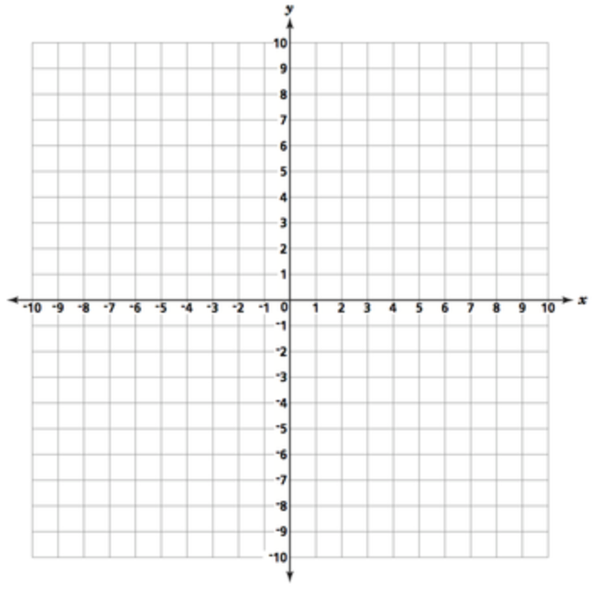

Question 9 2 marks
Write a rule for a parabola with each feature.
- Same shape as$y=x^{2}$, minimum turning point (1, 3)

- Same shape as$y=x^{2}$, maximum turning point (0, 2)

Question 10 2 marks
For the pair of parabolas described below, which one will be “wider” when compared to the other

- $y=x^{2}$ or $y={4x}^{2}$

- $y=x^{2}$ or $y={\frac{1}{2}x}^{2}$

Question 11 9 marks- 1, 1, 2, 2, 3
A circle has the following equation $x^{2}+ y^{2}=25$
- State the coordinates of the centre

- State the radius

- Find the values of $y$when $x$= 4

- Find the values of $x$when $y$= 0

- Sketch a circle graph with the equation $x^{2}+ y^{2}=25$



Question 12 8 marks- 2, 2, 2, 2
- Sketch by hand or using a classpad the following parabolas:
${y=x}^{2} and {y=(x+2)}^{2} and {y=(x-2)}^{2}$


- Describe how the value of “a” affects the graph of the parabola whose equation is ${y=(x+a)}^{2}$

End of Test

